6.Transfer of files from one Virtual Machine to another
Aim:
To transfer files from Ubuntu VM to Kali VM using NFS share, enabling read and write access on both ends.
Steps:
1.ConfigureVirtualBox Network
Set both VMs’ network adapter to "Host-only Adapter” in adapter 1 and NAT in adapter 2(for installing packages) so they are on the same subnet.
Go to settings -> network -> adapter 1-> Host only adapter and Adapter2-> NAT
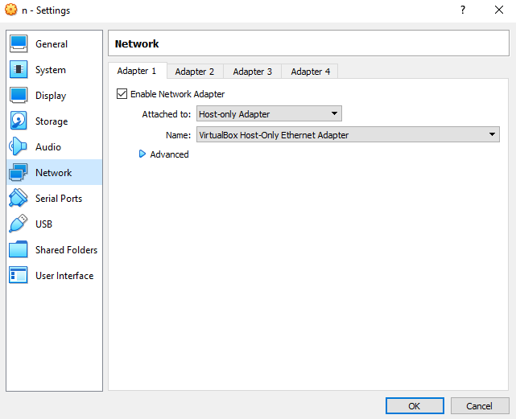
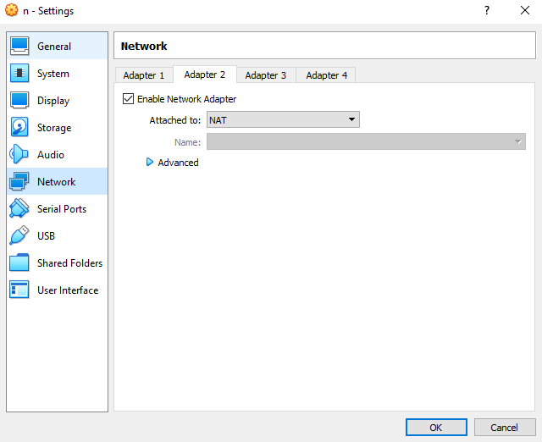

2. Check IP Addresses
On both ubuntu as well as kali ip a (check ip) Ensure both are in same subnet (eg 192.168.56.103/24 ubunttu and 192.168.56.104 kali) both in same subnet 192.168.56.0/24

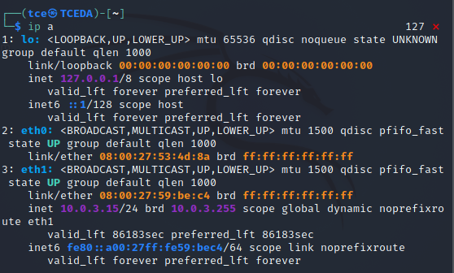
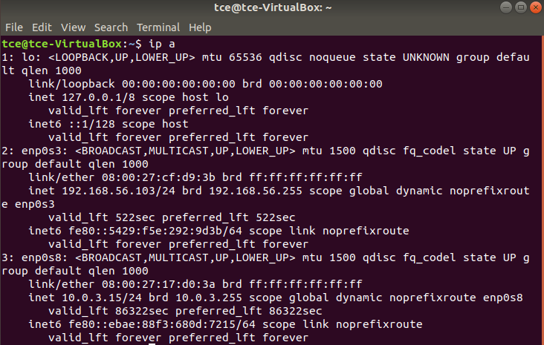
3. Set up NFS Server on Ubuntu VM(Here ubuntu act as server)
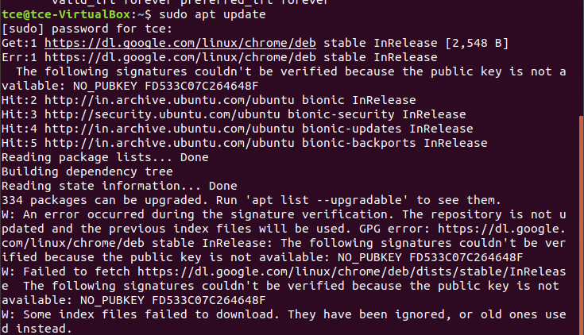
- Sudo apt update

- Update and install NFS server:
sudo apt update
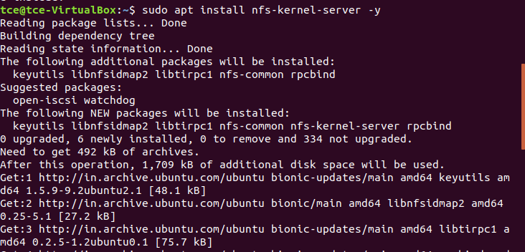
sudo apt install nfs-kernel-server -y

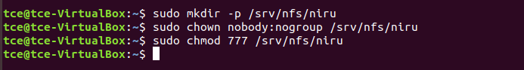
- Create folder to share:
sudomkdir -p /srv/nfs/sharedfolder (or any folder name)
- Set permissions:
  - sudochownnobody:nogroup /srv/nfs/sharedfolder
  - sudochmod 777 /srv/nfs/sharedfolder
- Edit exports file to allow Kali IP access:
sudonano /etc/exports (it open in nano editor)
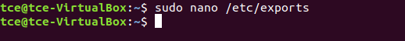
Add /srv/nfs/sharedfolder< kali ip>(rw,sync,no_subtree_check,no_root_squash)
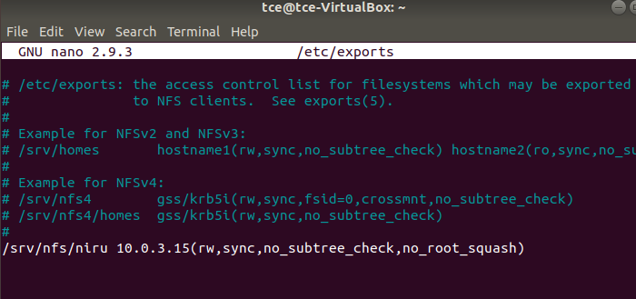
Click ctrl+o and enter and ctrl x ( to save and came out of nano editor)
- Export and restart NFS server:
sudoexportfs -a
sudosystemctl restart nfs-kernel-server
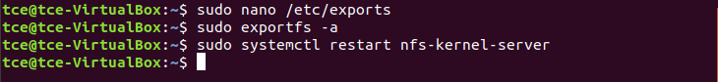
- Allow/disable the firewall for the kali linux(skipping shown already firewall in disable mode)

4. Set up NFS Client on Kali VM
- Install NFS client:
  - sudo apt update
  - sudo apt install nfs-common -y
(here apt update not work because of network is in off so go to wired connection top right corner change the wired connection(NAT) and after above two command change again the wired connection1(Host only adapter)
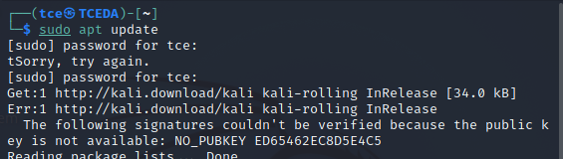
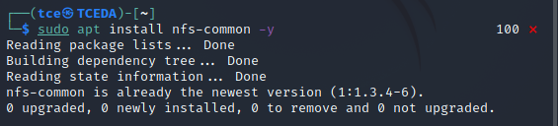
- Create mount point:
sudomkdir -p /mnt/nfs/sharedfolder
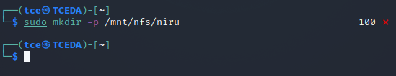
- Mount the NFS share:
sudo mount ubuntuip:/srv/nfs/dir _name /mnt/nfs/dir_name
eg:
sudo mount 192.168.56.103:/srv/nfs/sharedfolder /mnt/nfs/sharedfolder
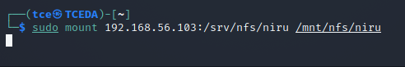
- Verify:
df -h | grepnfs
ls -l /mnt/nfs/sharedfolder
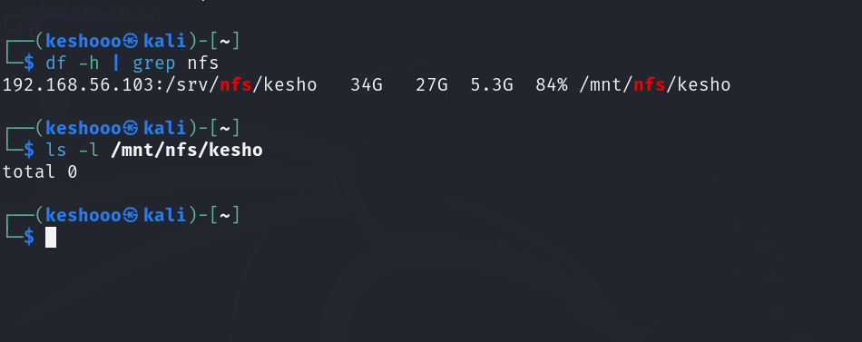

5. Test File Transfer
- On Ubuntu VM, create file:
echo "Hello from Ubuntu" | sudo tee /srv/nfs/dir_name/ubuntu_test.txt
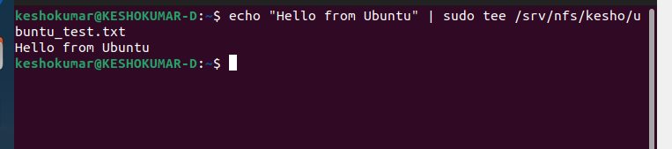
- On Kali VM, verify(READ OPERATION)
ls -l /mnt/nfs/sharedfolder
cat /mnt/nfs/sharedfolder/ubuntu_test.txt

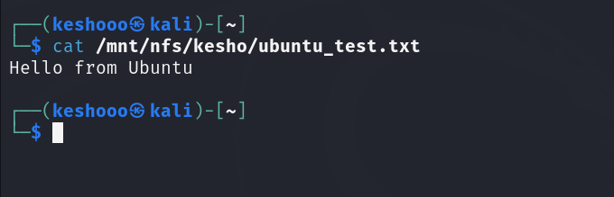

- On Kali VM, (WRITE OPERATION):
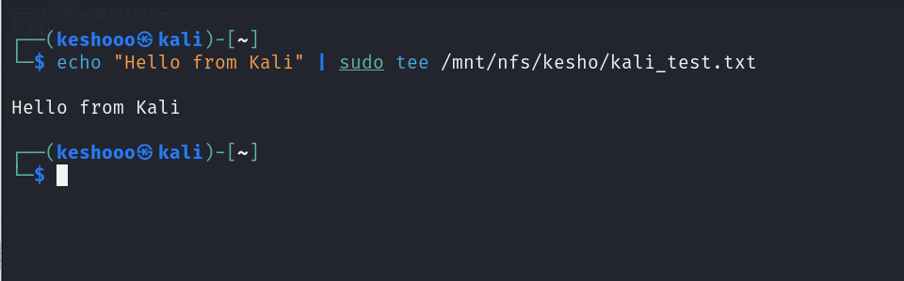
- On Ubuntu VM, verify
ls -l /srv/nfs/sharedfolder
cat /srv/nfs/sharedfolder/kali_test.txt

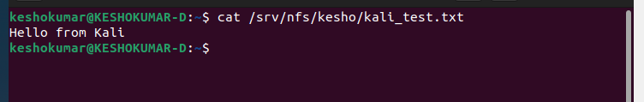

METHOD 2
SHARED FOLDER
Step 1: Create a Shared Folder on Your Host
- On your host machine (Windows/Linux):
  - Create a folder, e.g., C:\VMShared

  - Add a test file (22IT043.txt) to confirm later.
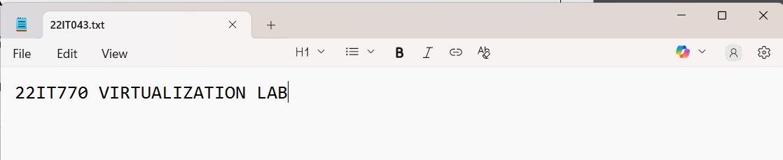
Step 2: Enable Shared Folder in VirtualBox (for Both VMs)
Repeat this for both Ubuntu VMs.
- Shut down the VM if it’s running.
- In VirtualBox Manager, select your VM.
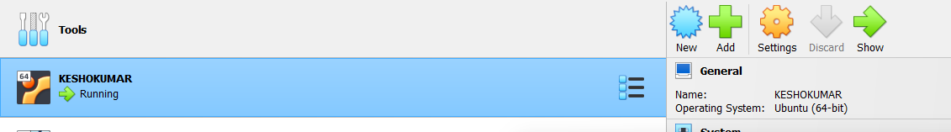
- Click Settings → Go to Shared Folders tab.
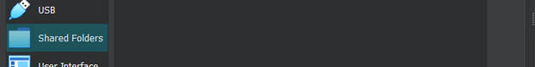

- Click “+” (Add new shared folder).
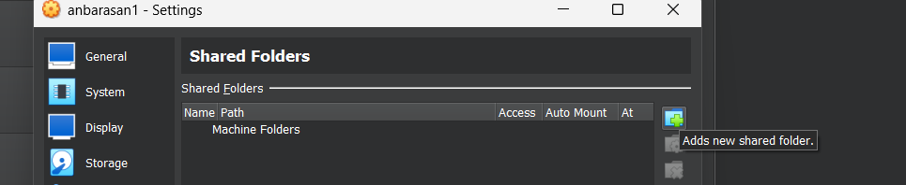
- Set:
  - Folder Path: Select C:\VMShared (or wherever you created it).
  - Folder Name: VMShared (updates once path is entered)
  - Check(Tick) Auto-mount
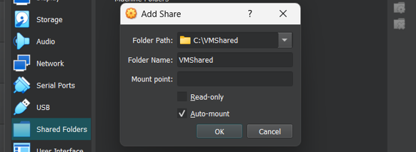
Click OK.
- Then, again Click OK (at bottom) to save.
Do this for both VMs
VM2:
3.InVirtualBox menu (inside VM window), go to:Devices → Insert Guest Additions CD image
VM1:
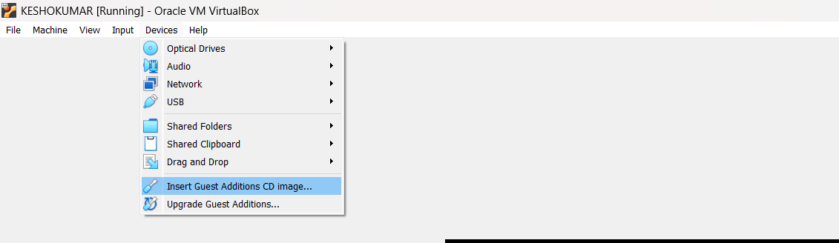

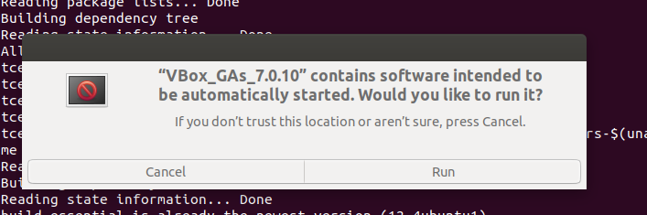

Now use the command: ls /media
- It lists all the directories (i.e., mounted devices or drives) under the /media directory.
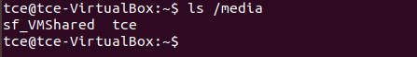
Therefore, in VM1 sf_VMShared folder is there in /media directory.
VM2: SAME PROCEDURE FOR virtualbox 2
Run the command: ls /media
Therefore, in VM2 also sf_VMShared folder is there in /media directory.
Step 4: Access the Shared Folder
After rebooting each VM, the shared folder should be mounted automatically at: /media/sf_VMShared
To check, run the command :ls /media
VM1 :
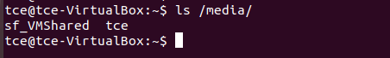
VM2 :
Run the command :ls /media/sf_VMShared
VM1 :
VM2 :
You should see the 22IT043.txt file from your host.
But in VM1 and VM2 , it asks for permission to list the files of sf_VMShared folder.
Step 5: Fix Permissions (if Permission Denied)
You need to add your user to the vboxsf group:
sudousermod -aGvboxsf $USER
Then reboot again:
sudo reboot
Now try again:
ls /media/sf_VMShared``
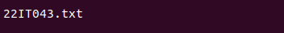
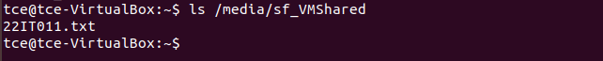
You should now have full access.
Step 6: Transfer Files Between VMs
- Trying to print the content of 22IT043.txt file from VM1

- Now in VM1, copy a file to /media/sf_VMShared folder,
cp VM1.txt /media/sf_VMShared/
- Switch to VM2, and check the shared folder:
ls /media/sf_VMShared
The VM1.txt file will appear — you can copy it out to any other location and also you can edit files in shared folder location itself. Any changes done in shared folder using one VM will also be reflected to the other VM.
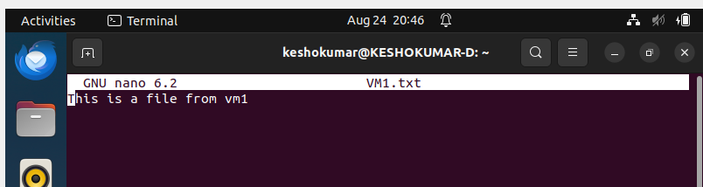
Also 22IT043.txt file is accessible in VM2,
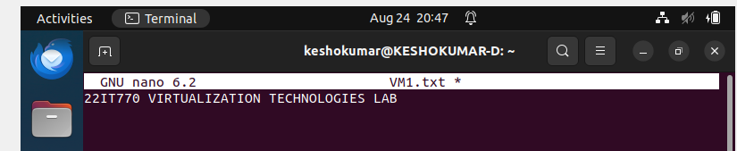

METHOD 3(SSHSecure Shell)
Step 1: Install SSH
On both VMs (VM1 & VM2):
sudo apt update
sudo apt install openssh-server -y
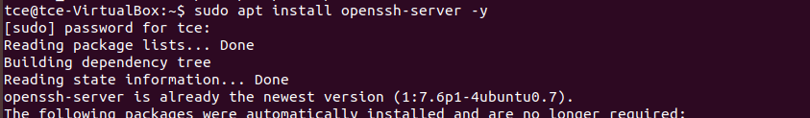
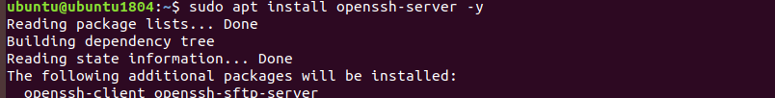
Check SSH status:
sudosystemctl status ssh
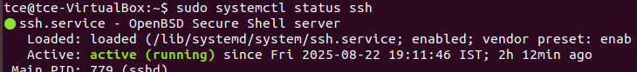
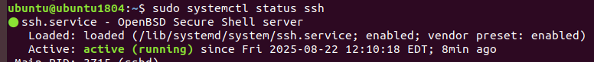
Step 2: Get Server’s IP
On VM1 (Server, username = tce):ip a
Allow firewall settings for SSH to avoid Connection timed out error.
sudoufw allow 22/tcp
sudoufw reload
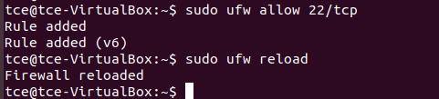
Step 3: Connect from VM2 to VM1
On VM2 (Client, username = ubuntu):
ssh tce@192.168.56.103
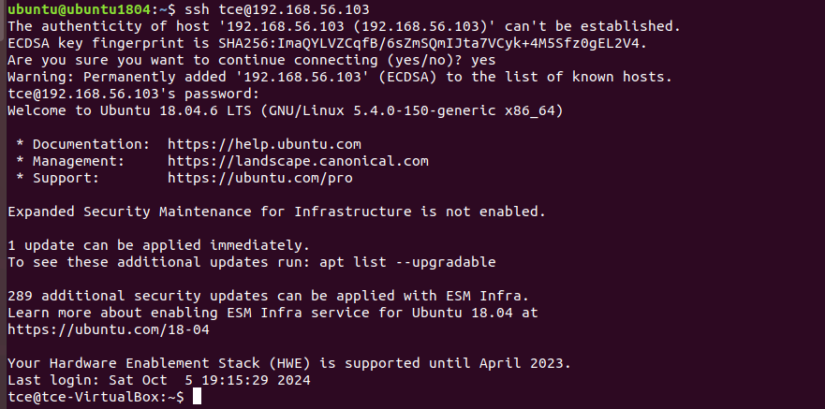Enter tce’s password → now you are logged into VM1.
Step 4: Transfer Files with SCP (From VM2)
(a) Copy file from VM2 → VM1
scp file.txt tce@192.168.56.103:/home/tce/
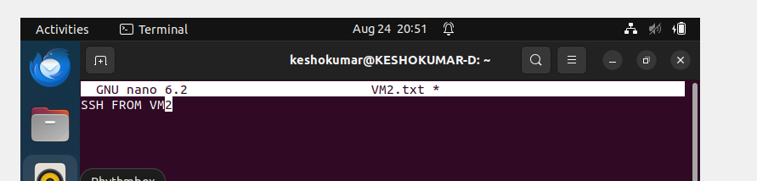

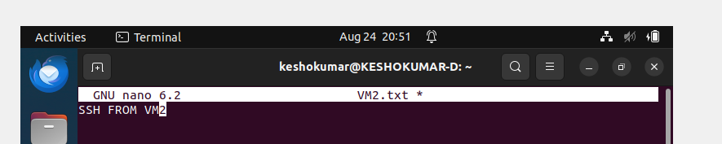
(b) Copy file from VM1 → VM2
scp tce@192.168.56.103:/home/tce/serverfile.txt /home/ubuntu/
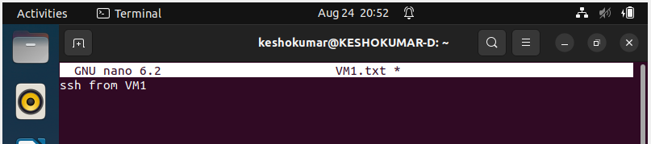
METHOD 4(FTP (File Transfer Protocol)
Step 1: Install FTP Server on VM1
(VM1 = server, VM2 = client)
On VM1:
sudo apt update

sudo apt install vsftpd -y
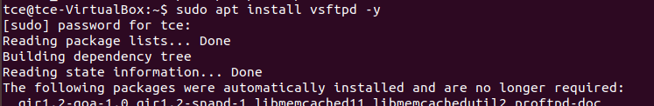
Enable and start the service:
sudosystemctl enable vsftpd
sudosystemctl start vsftpd
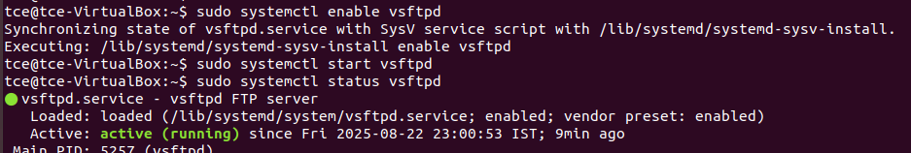
Step 2: Configure vsftpd
Edit the config file:
sudonano /etc/vsftpd.conf
Make sure these lines are set (uncomment or add if missing):
local_enable=YES
write_enable=YES
chroot_local_user=YES
allow_writeable_chroot=YES
Save (CTRL+S, CTRL+X)
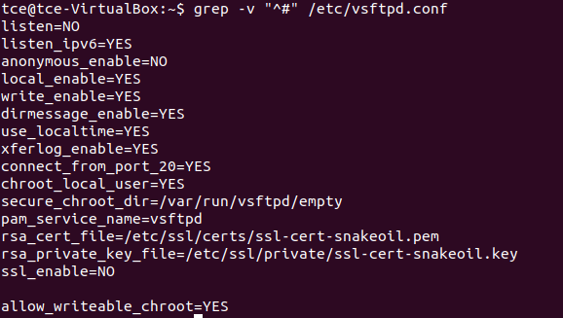
Restart the ftp server:
sudosystemctl restart vsftpd
Step 3: Check VM1 IP Address
On VM1, run:
ip a
Allow firewall settings for FTP to avoid Connection timed out error.
sudoufw allow 21/tcp
sudoufw allow 20/tcp # (for data transfer)
sudoufw status
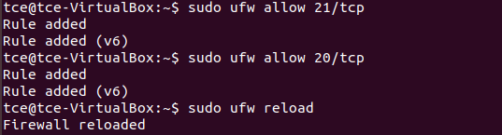

Step 4: Connect from VM2 (FTP client)
On VM2, install ftp client:
sudo apt install ftp -y
Now connect:
ftp 192.168.56.103
Enter VM1’s username (tce) and password when prompted.
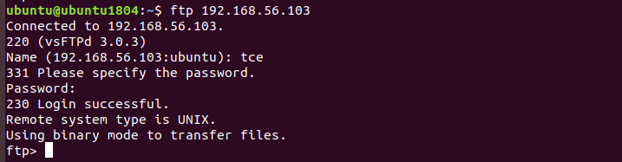
Step 5: FTP Commands
Once connected, you can use:
- ls → list files on VM1
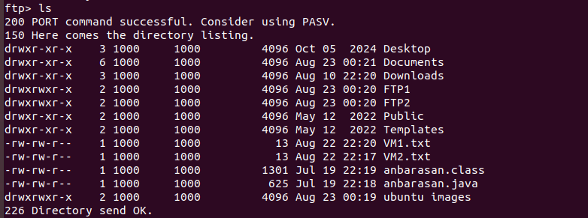
- cd folder → change directory on VM1
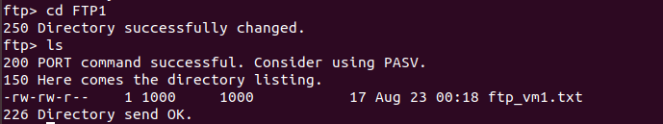
- get filename → download file from VM1 → VM2
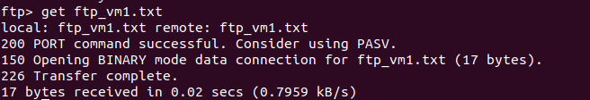
- put filename → upload file from VM2 → VM1
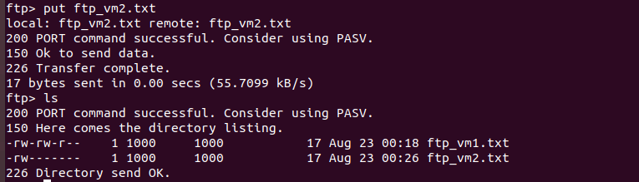
- bye → exit
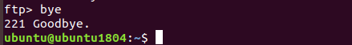
Step 6: Verify
- ftp_vm1.txt should now be in VM2’s current directory.
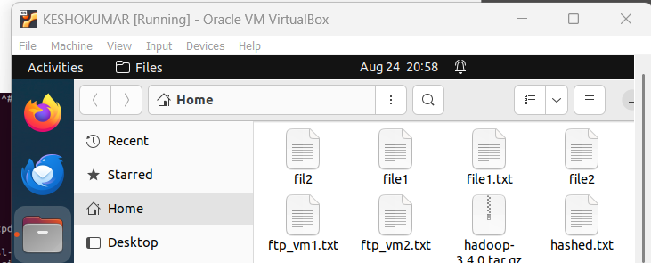

- ftp_vm2.txt should now be uploaded to VM1’s /home/FTP1/ directory.
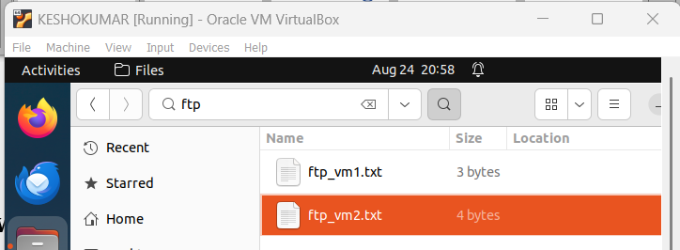

RESULT:
Thus the file transfer between Ubuntu and Kali VMs is executed successfully and both VMs can read and write files in the shared folder seamlessly.

